You are given an integer array nums of 2 * n integers. You need to partition nums into **two** arrays of length n to **minimize the absolute difference** of the **sums** of the arrays. To partition nums, put each element of nums into **one** of the two arrays.

Return *the* ***minimum*** *possible absolute difference*.

**Example 1:**

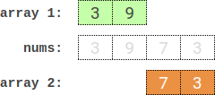

Input: nums = [3,9,7,3]  
Output: 2  
Explanation: One optimal partition is: [3,9] and [7,3].  
The absolute difference between the sums of the arrays is abs((3 + 9) - (7 + 3)) = 2.

**Example 2:**

Input: nums = [-36,36]  
Output: 72  
Explanation: One optimal partition is: [-36] and [36].  
The absolute difference between the sums of the arrays is abs((-36) - (36)) = 72.

**Example 3:**

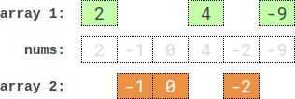

Input: nums = [2,-1,0,4,-2,-9]  
Output: 0  
Explanation: One optimal partition is: [2,4,-9] and [-1,0,-2].  
The absolute difference between the sums of the arrays is abs((2 + 4 + -9) - (-1 + 0 + -2)) = 0.

**Constraints:**

* 1 <= n <= 15
* nums.length == 2 * n
* -107 <= nums[i] <= 107